**Temperature Forecast Project using ML**

## **Table of Contents**

1. **Problem Definition**
   * Objective
   * Context
   * Data Description
   * Methodology
   * Expected Outcome
2. **Data Analysis**
3. **Exploratory Data Analysis (EDA)**
4. **Pre-processing Pipeline**
   * Handling Missing Values
   * Feature Engineering
   * Data Normalization
   * Splitting Data for Training and Testing
5. **Building Machine Learning Models**
   * Find the best Random score
   * Find the best model
   * Hyperparameter Tuning (Find the best parameters)
   * Create the best model
   * Saving the model
   * Testing the model
6. **Concluding Remarks**
   * Summary of Findings
   * Outcome
   * Final Thoughts
7. **Problem definition**

The goal of this project is to enhance the accuracy of temperature forecasts in Seoul, South Korea, using historical weather data provided by the Korea Meteorological Administration. Specifically, the project focuses on predicting the next day's maximum and minimum temperatures during the summer months over a five-year period from 2013 to 2017.

**Objectives**

* **Next day maximum temperature prediction**: Develop a regression model that accurately forecasts the maximum temperature for the next day using the provided data.
* **Next Day Minimum Temperature Prediction**: Develop a regression model that accurately forecasts the minimum temperature for the next day using the provided data.

**Context**

Accurate weather forecasting is critical for various sectors including agriculture, energy, health, and daily life activities. Existing forecasting models, such as the LDAPS (Local Data Assimilation and Prediction System), provide next-day temperature predictions, but there is always room for improvement in their accuracy. This project aims to refine these predictions using regression analysis, leveraging historical data and geographic auxiliary variables.

**Data Description**

The dataset includes:

1. **LDAPS Model's Next-Day Forecast Data**: This data comprises the predicted maximum and minimum temperatures for the next day as forecasted by the LDAPS model.
2. **In-situ Temperature Data**: Actual observed maximum and minimum temperatures for each day within the given period.
3. **Geographic Auxiliary Variables**: Additional variables that might influence forecast stations, latitude, longitude etc.

**Methodology**

The approach involves:

1. **Data preprocessing**: Cleaning and preparing the data for analysis, including handling missing values, normalizing data, and selecting relevant features.
2. **Feature selection**: Identifying the most significant variables that influence temperature variations.
3. **Model development** : Using regression analysis techniques to create predictive models. This might include linear regression, polynomial regression, or more advanced methods like support vector regression or neural networks.
4. **Model Evaluation**: Assessing the performance of the models using appropriate metrics such as Mean Absolute Error (MAE), Mean Squared Error (MSE), and R-squared (R²).
5. **Model Optimization**: Fine-tuning the models to enhance their predictive accuracy.

**Expected Outcome**

By the end of this project, we aim to have developed robust regression models capable of providing more accurate predictions for the next day's maximum and minimum temperatures in Seoul. This improved forecasting can contribute to better preparedness and decision-making in various weather-dependent activities.

This problem definition sets the stage for a systematic approach to enhancing weather forecasts, leveraging historical data and modern regression techniques to achieve better predictive performance.

1. **Data Analysis**

**Importing Required Libraries**

* To begin the analysis, we need to import several essential libraries. These libraries provide various functions and tools for data manipulation, visualization, and machine learning, which include:

1. Pandas
2. Seaborn
3. Matplotlib
4. NumPy
5. Sci-kit learn

**Importing the Dataset**

* Next, we import the dataset using pandas and create a DataFrame. Pandas is a powerful library that provides data structures like DataFrame, which is perfect for handling tabular data.

**Checking Dataset Details**

* After loading the dataset, it's crucial to understand its structure and content. The **df.info()** method provides a concise summary of the DataFrame, including the number of non-null entries, column names, data types, and memory usage.

**Checking Dataset Shape**

* The **df.shape** attribute returns a tuple representing the dimensionality of the DataFrame. It provides the number of rows and columns, which helps in understanding the size of the dataset.

**Descriptive statistics:**

* Descriptive statistics provide a summary of the central tendency, dispersion, and shape of the dataset’s distribution. The **df.describe()** method calculates these statistics for numerical columns by default. To include all columns (numerical and categorical), we use **df.describe(include='all')**

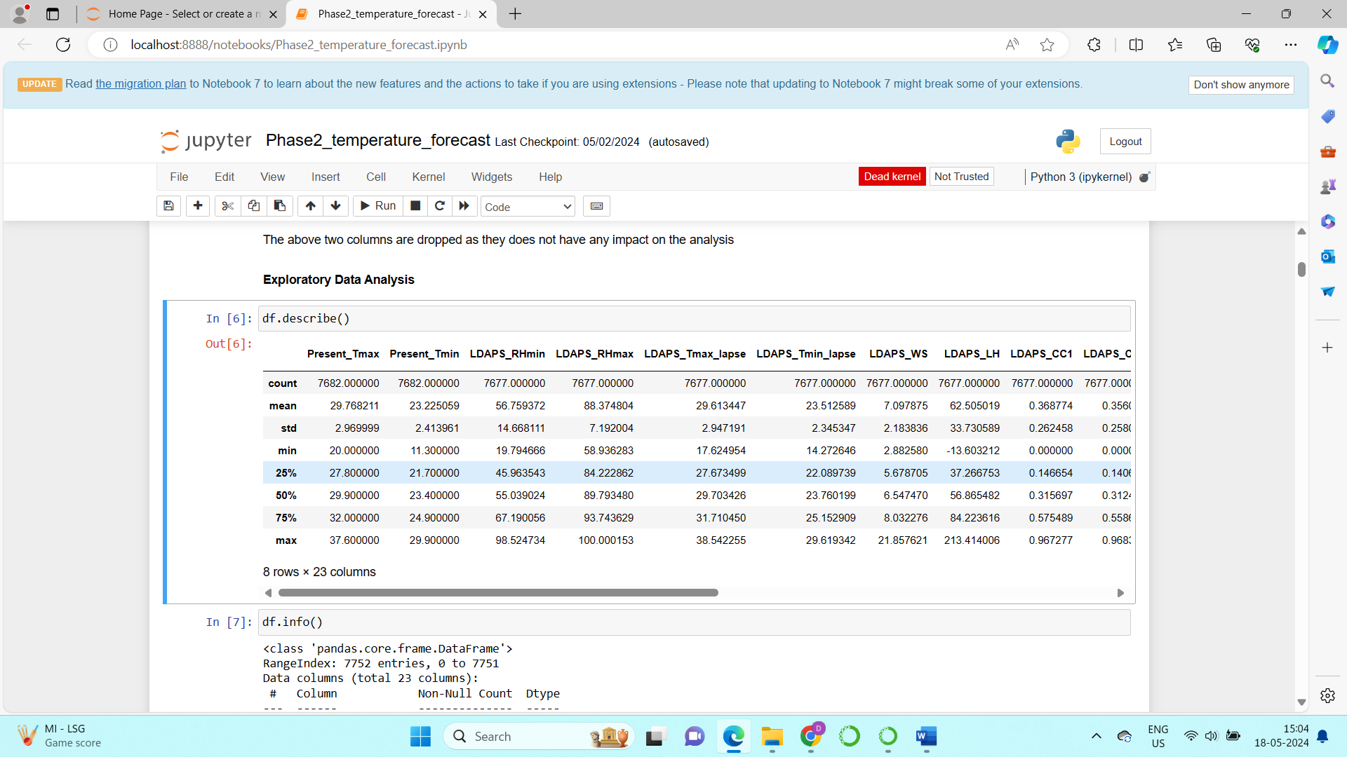

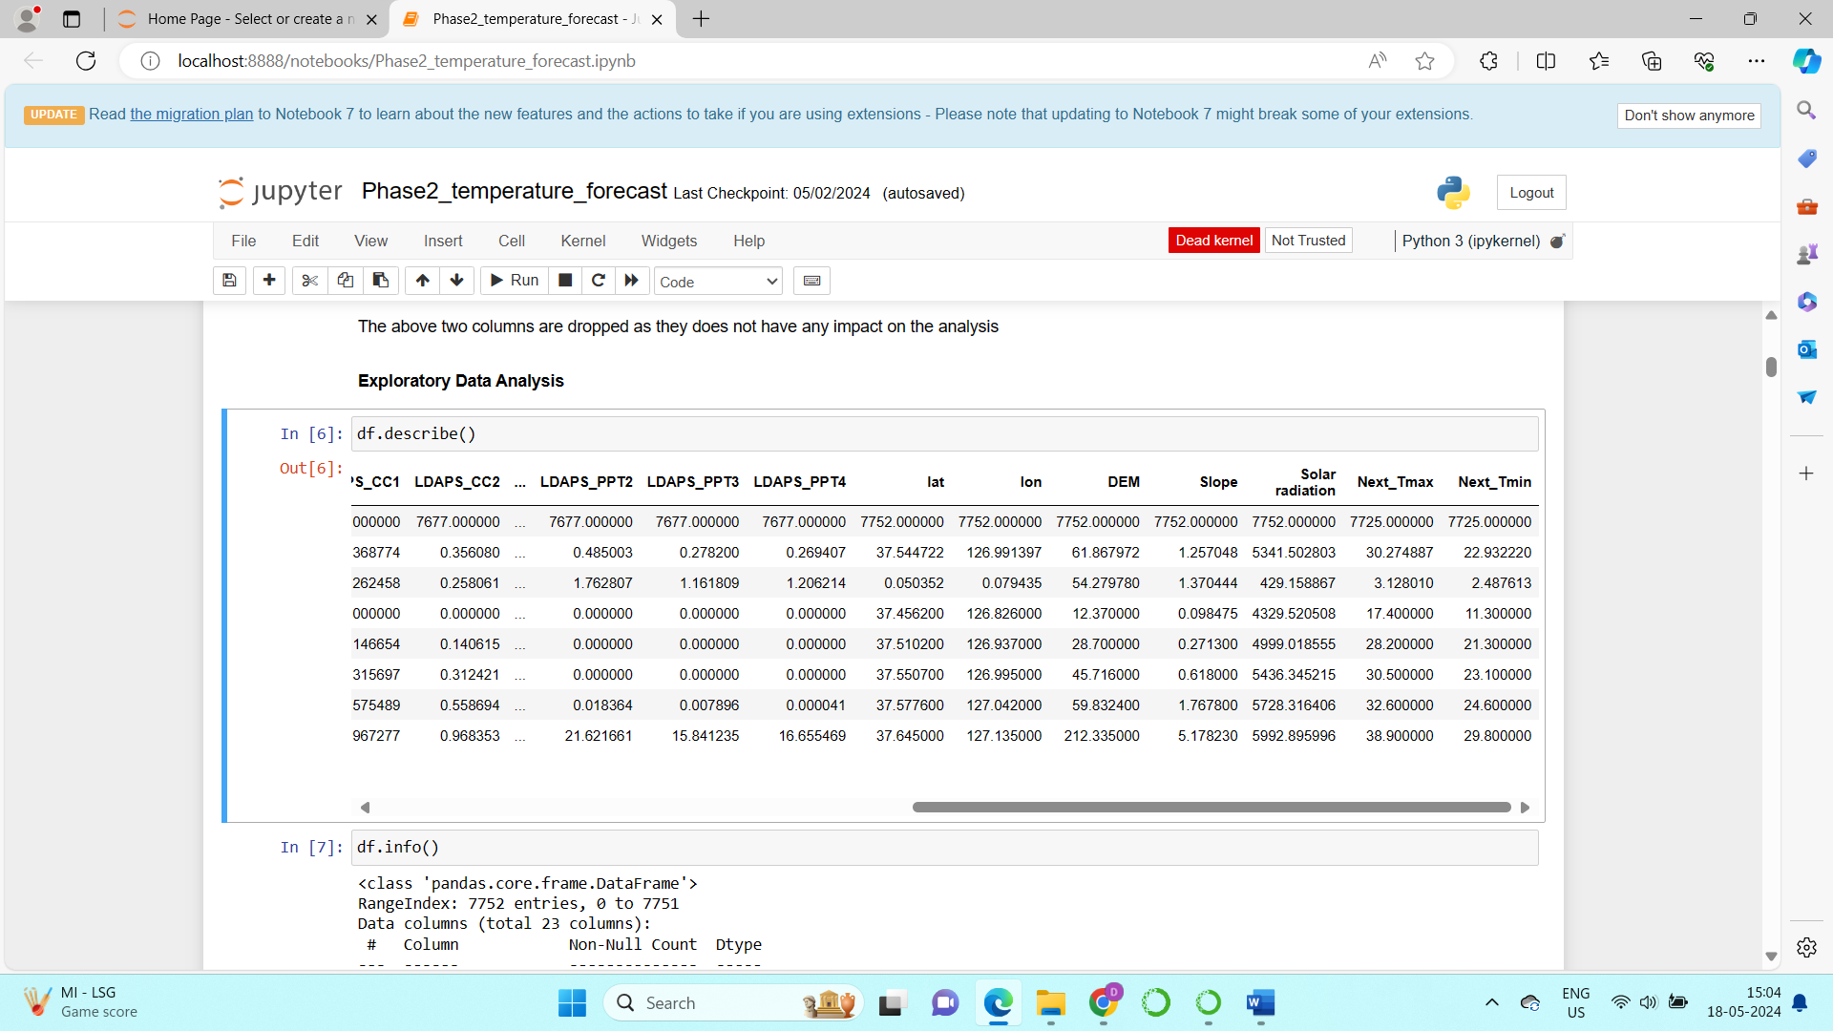

**Descriptive Statistics Insights**

The descriptive statistics provide valuable insights into the distribution and properties of the dataset's features. Here’s a more detailed look at the observations:

**a) Normal Distribution of Features**

**Present_Tmax and Present_Tmin**:

* These features, representing the present day's maximum and minimum temperatures, appear to be normally distributed. This can be inferred from the summary statistics showing that the mean and median are close to each other and the spread (standard deviation) is relatively consistent without extreme values.
* In a normal distribution, the mean, median, and mode are approximately equal, and the data is symmetrically distributed around the mean.

**b) Skewness in Specific Features**

**LDAPS_LH, LDAPS_PPT1, LDAPS_PPT2, LDAPS_PPT3**:

* These features exhibit skewness, which is apparent from the differences between the 75th percentile and the maximum value. A large gap between these percentiles suggests that there are outliers or a long tail in the distribution.
* **Skewness Identification**: For each of these features, the fact that the maximum value is much higher than the 75th percentile indicates that the data is skewed.

**c) Right Skewness of Features**

**Right Skewness (Positive Skewness)**:

* **Mean > Median**: When the mean is greater than the median, the distribution is right-skewed. This means there are a few high-value outliers pulling the mean upwards.
* For the features LDAPS_LH, LDAPS_PPT1, LDAPS_PPT2, and LDAPS_PPT3, the mean is significantly higher than the median, confirming the presence of right skewness.

1. **Exploratory Data analysis**

**Check for duplicates**:

* Drop the duplicate values present in the dataset, as the data will be inappropriate for creating the model.

**Check for null values**:

* We have seen that there are null values present in the dataset , but those are very less which can be removed in the preprocessing stage.

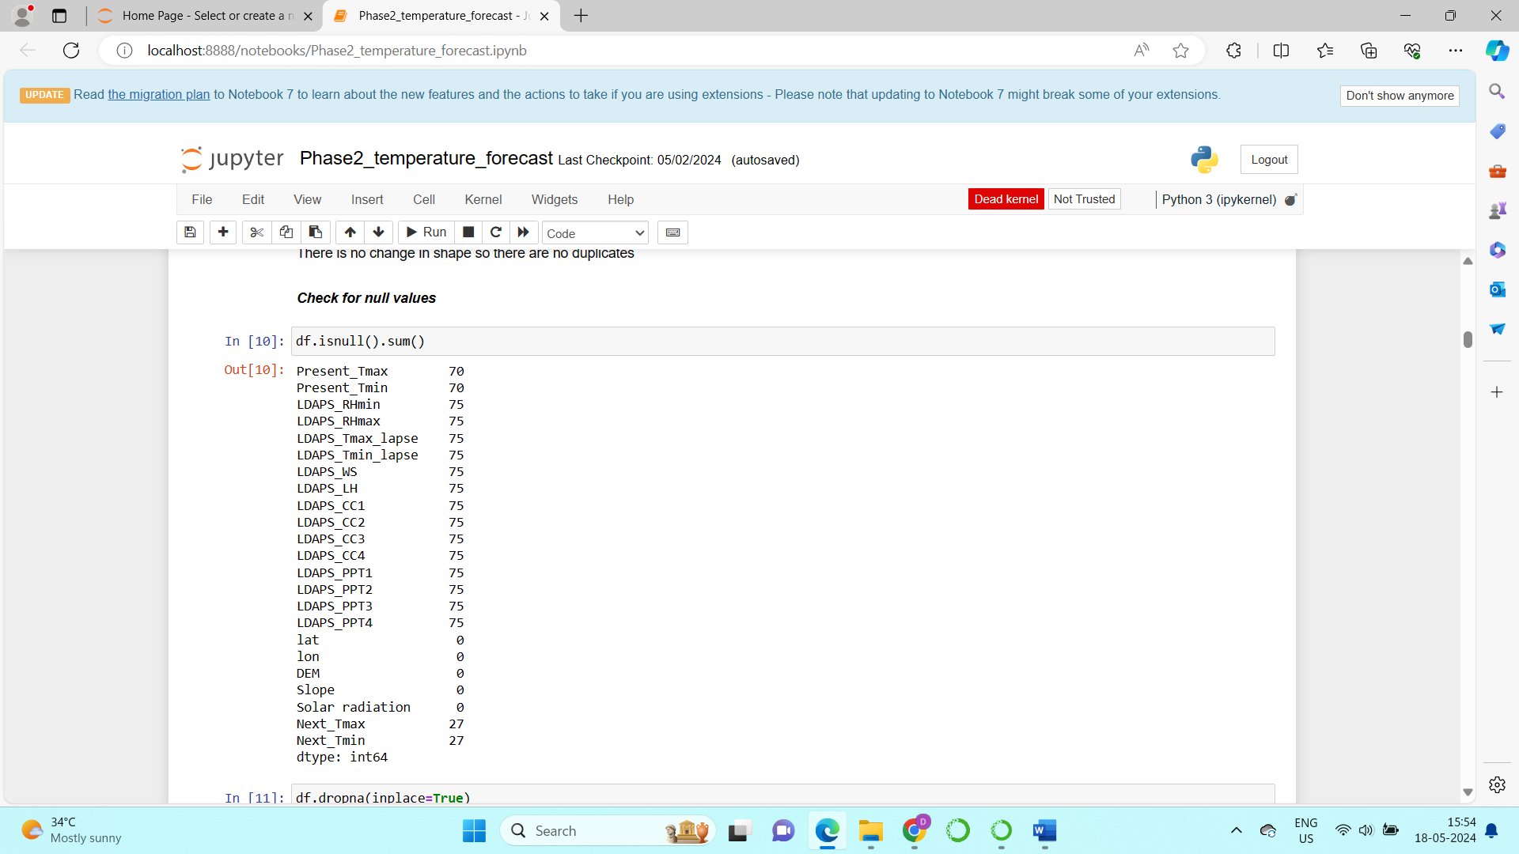

**Check for outliers**:

* For identifying the outliers we can use the boxplot, from which we can identify the outliers
* The values that lie out of the range of the max and min values are outliers
* These outliers can be visualized in the below images

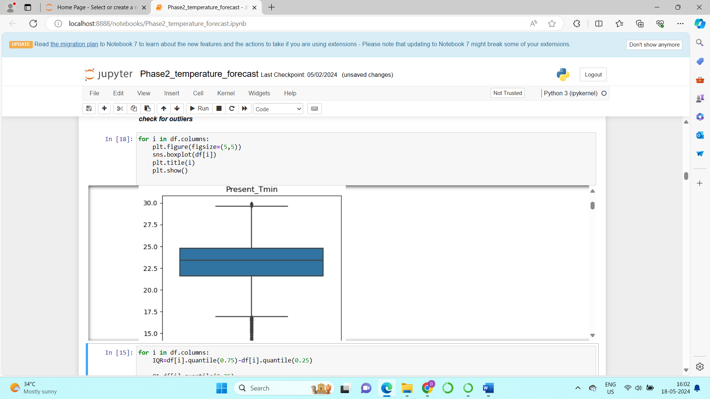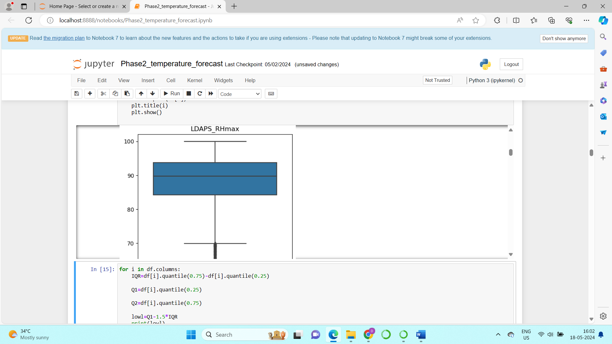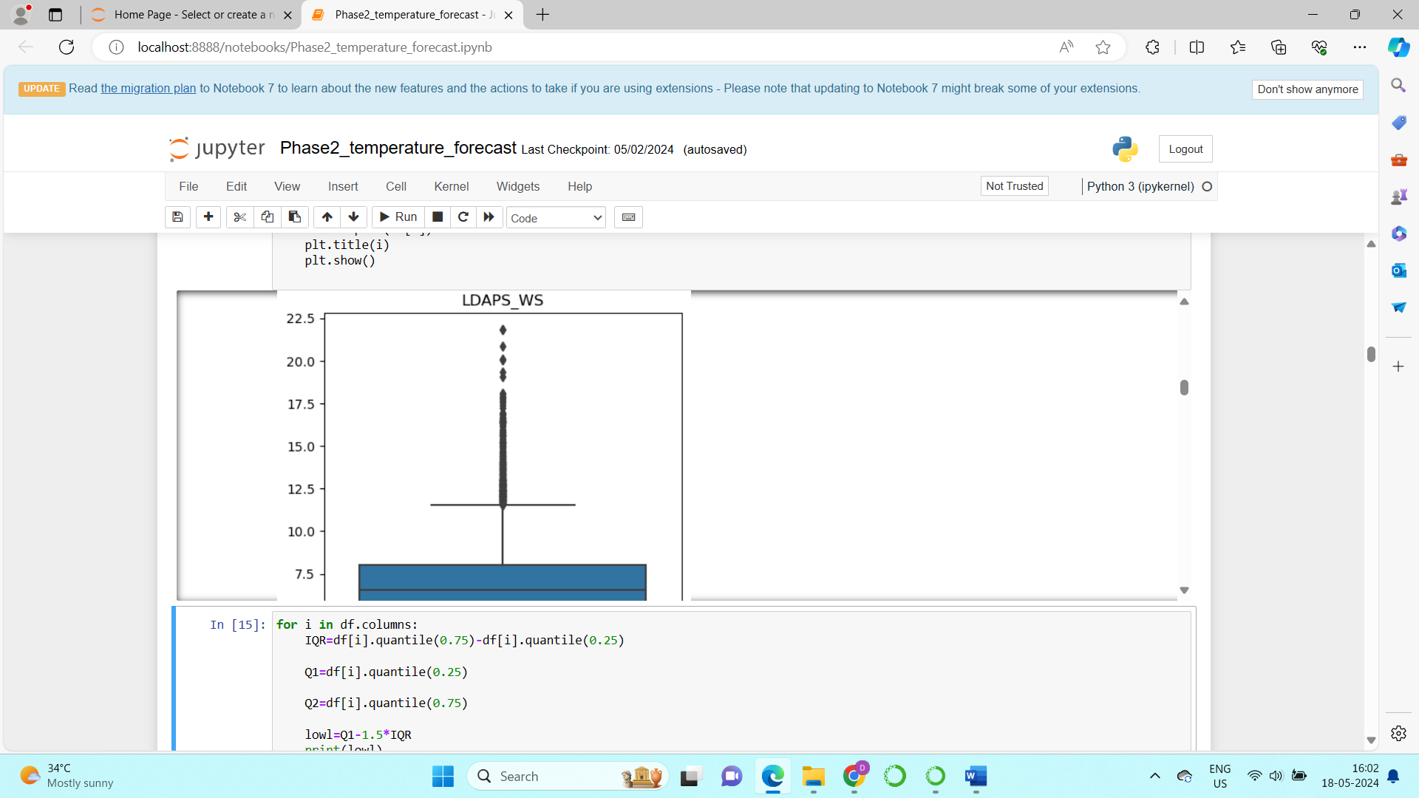

From the above 3 images we can see that there are outliers present, the black dots that appear as a strip are the outliers which are present

There are outliers present in the other features also those need to be rectified in the pre-processing stage.

**Check for skewness**:

* Skewness is one of another important factors that result in giving wrong results, we have already seen that there is some skewness present in some of the features in the descriptive statistics.
* Now we can visualize with the help of distplot in seaborn that can be seen in the below images.

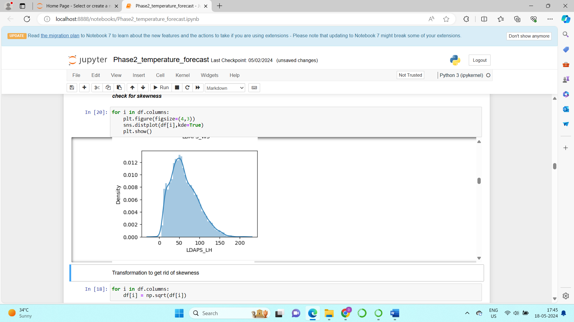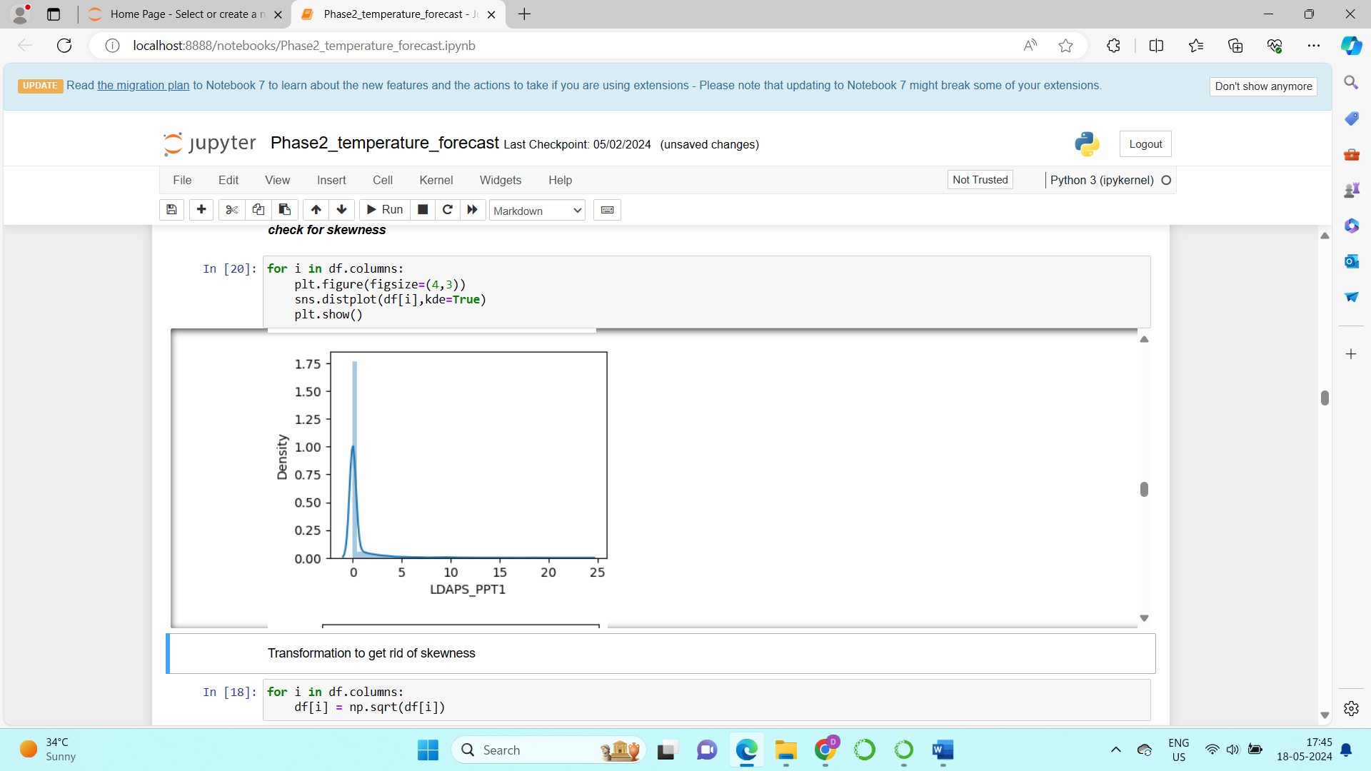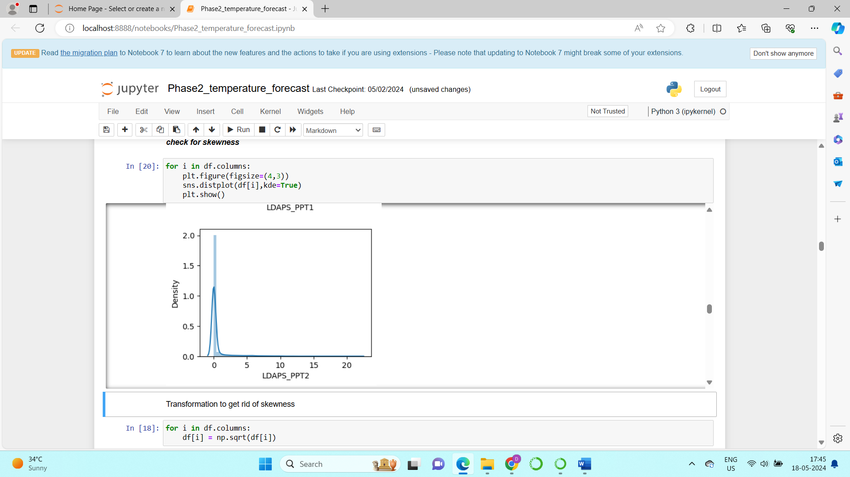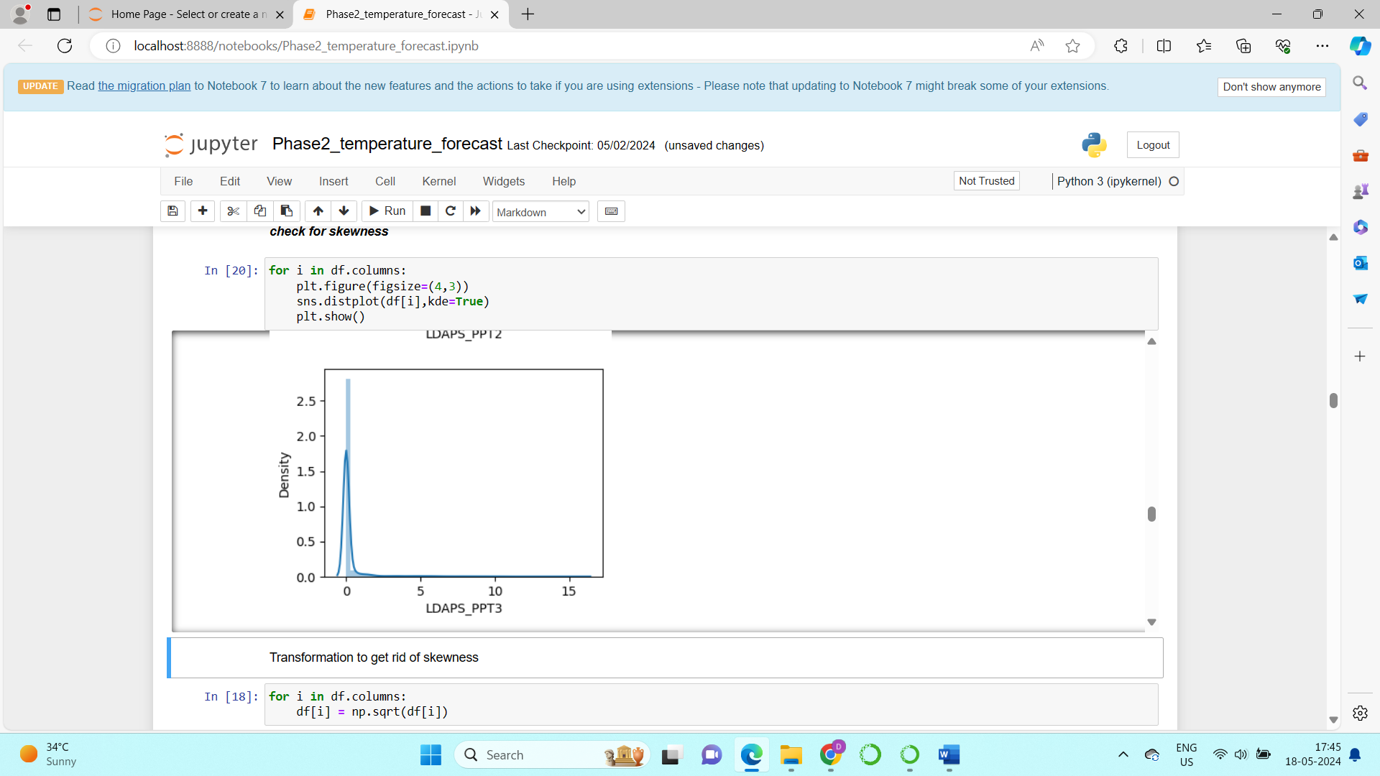

1. **Data Pre processing**

**Handling of missing values:**

In the dataset, there are a few rows with missing values. Since these missing values constitute a small portion of the dataset, removing these rows will not significantly affect the overall dataset or the results of the analysis.

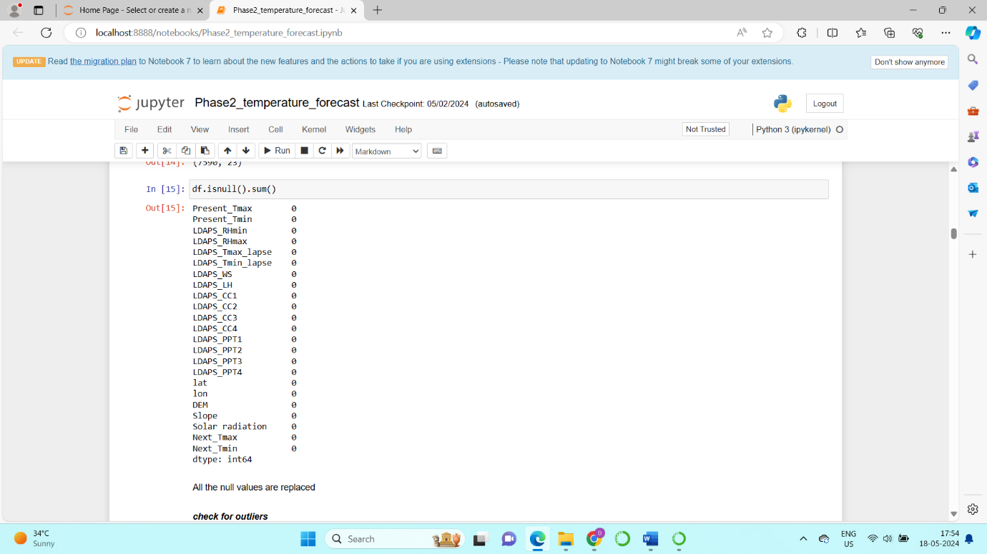

**Handling of outliers:**

When dealing with outliers in a dataset, it's often impractical to simply remove all of them, especially if they constitute a significant portion of the data. Instead, we can use a technique called capping , which limits the extreme values to reduce their impact on the analysis and model building. The Interquartile Range (IQR) method is a common approach for this.

The Interquartile Range (IQR) method is used to detect and handle outliers based on the distribution of the data:

* **IQR**: The range between the 25th percentile (Q1) and the 75th percentile (Q3) of the data.
* **Outliers**: Typically, values below Q1 - 1.5*IQR or above Q3 + 1.5*IQR are considered outliers.

**Capping Outliers**

Capping involves setting outlier values to a specified limit, usually the threshold values identified by the IQR method. This way, extreme values are brought closer to the main body of the data, reducing their influence while preserving the overall dataset.

The below image shows the syntax that I have used to remove outliers using IQR method:

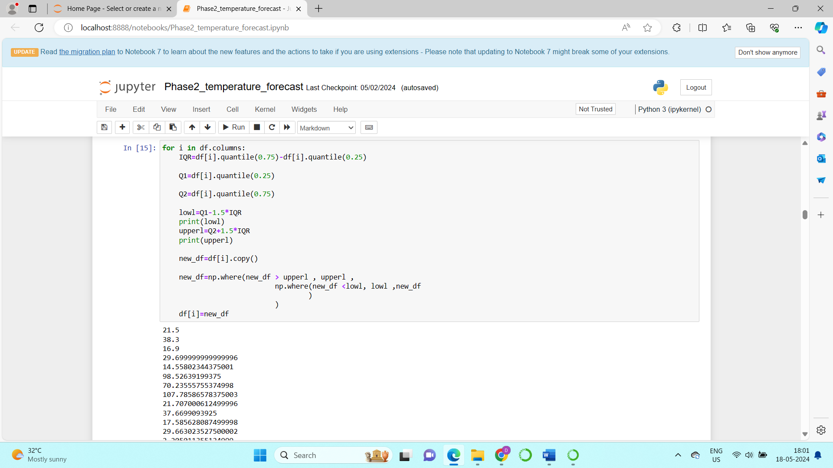

**Handling of skewness:**

In datasets with skewed features, applying transformations can help achieve a more normal distribution, improving the performance and accuracy of statistical analyses and machine learning models. Common transformation methods include log, square, and cube transformations. However, each method has its own suitability depending on the nature of the data.

For this particular dataset, we have chosen to use the square transform to handle skewness for as it is appropriate for the data we have.

The below image shows how it is applied and how the Skewness is somewhat reduced.

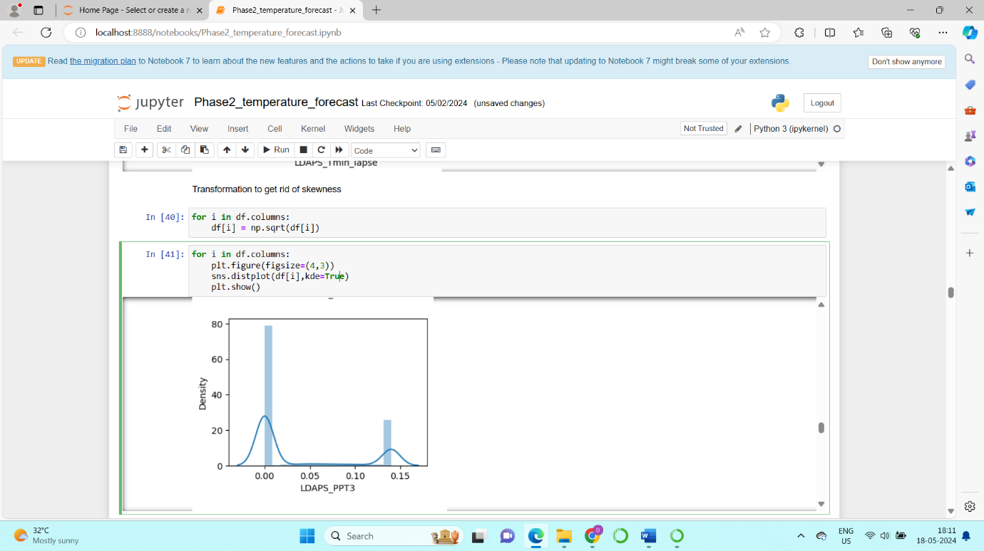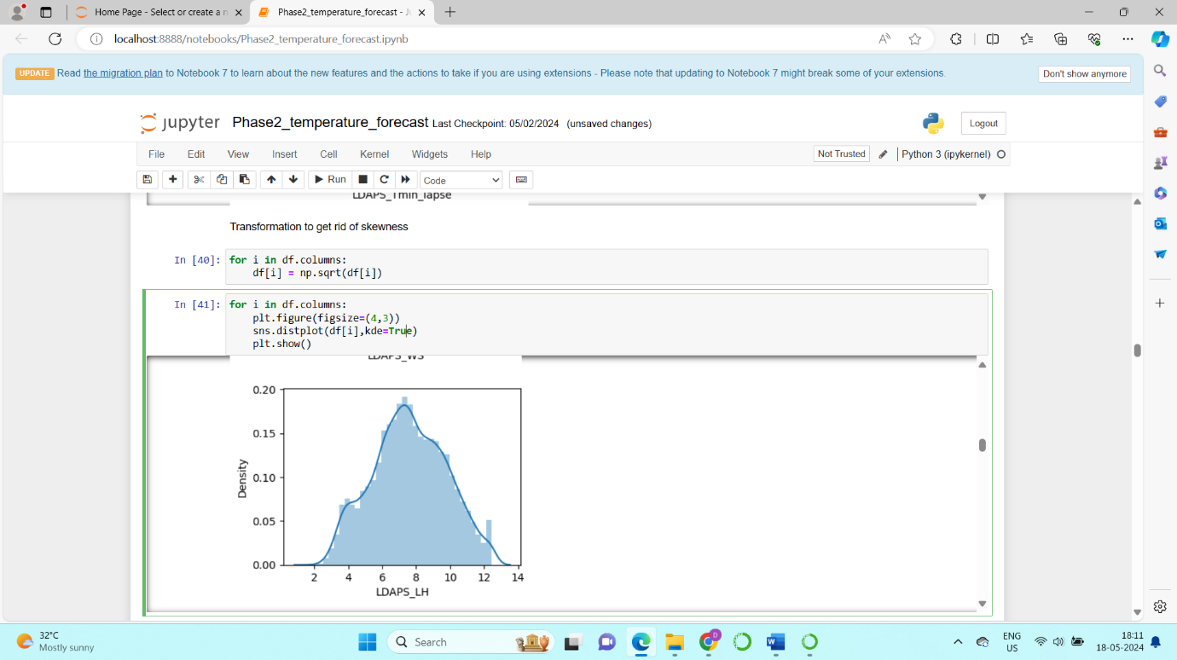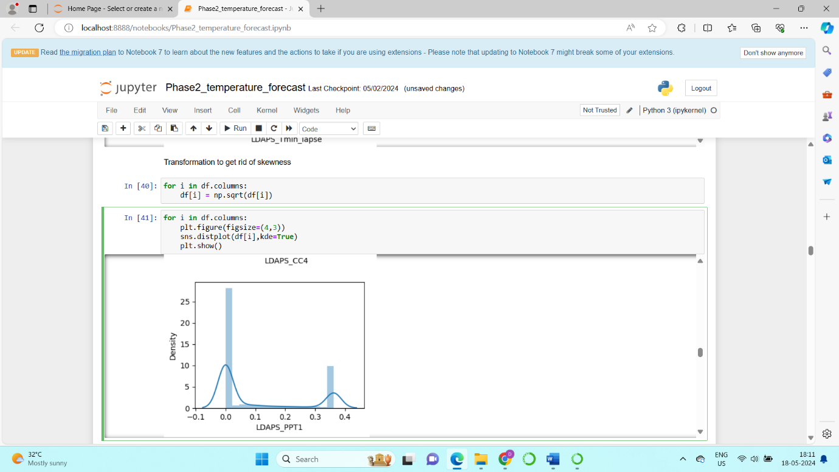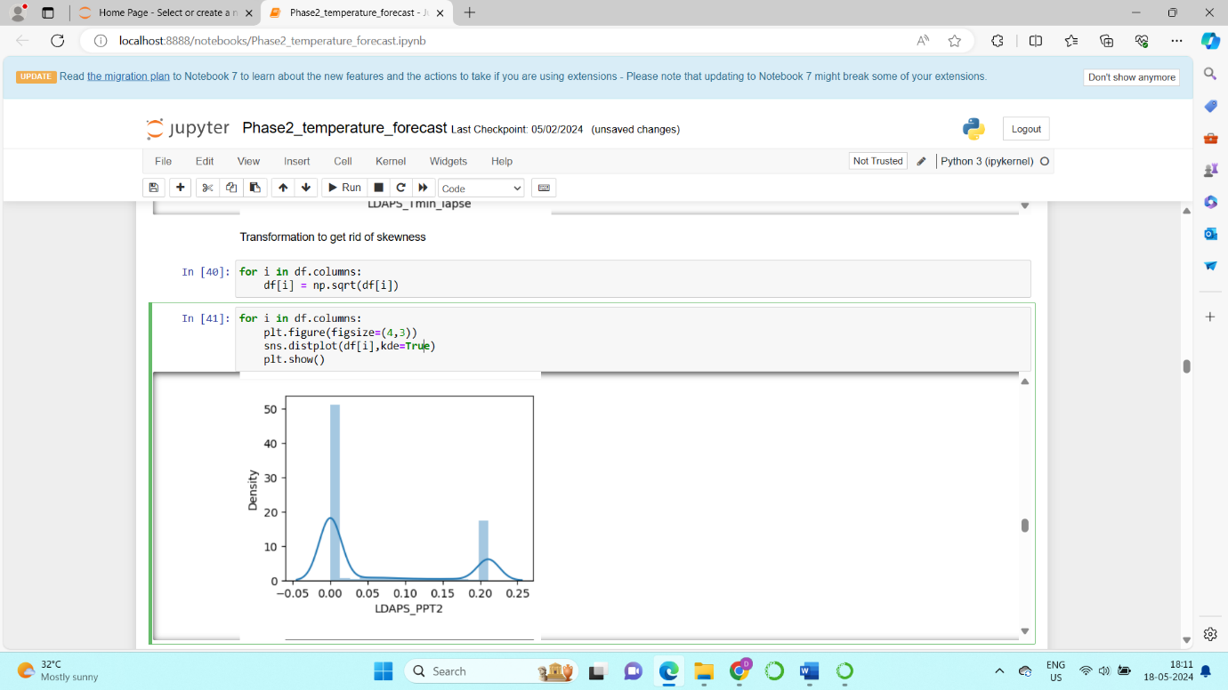

**Feature engineering:**

Feature engineering is the process of creating new features or modifying existing ones to improve the performance of machine learning models. In the context of our dataset on the temperature of South Korea, feature engineering can play a critical role in enhancing the predictive power of the models for forecasting next-day maximum and minimum temperatures.

* I have dropped 2 features “Station” and “Date” as these have the least importance.

**Correlation between features:**

* Now next process we can go to select the features is Correlation.
* We have to remove high correlation between the features, as these can create a noise in the data, which will create a wrong prediction by the model.
* So, for this we can get correlation with features using the below syntax mentioned

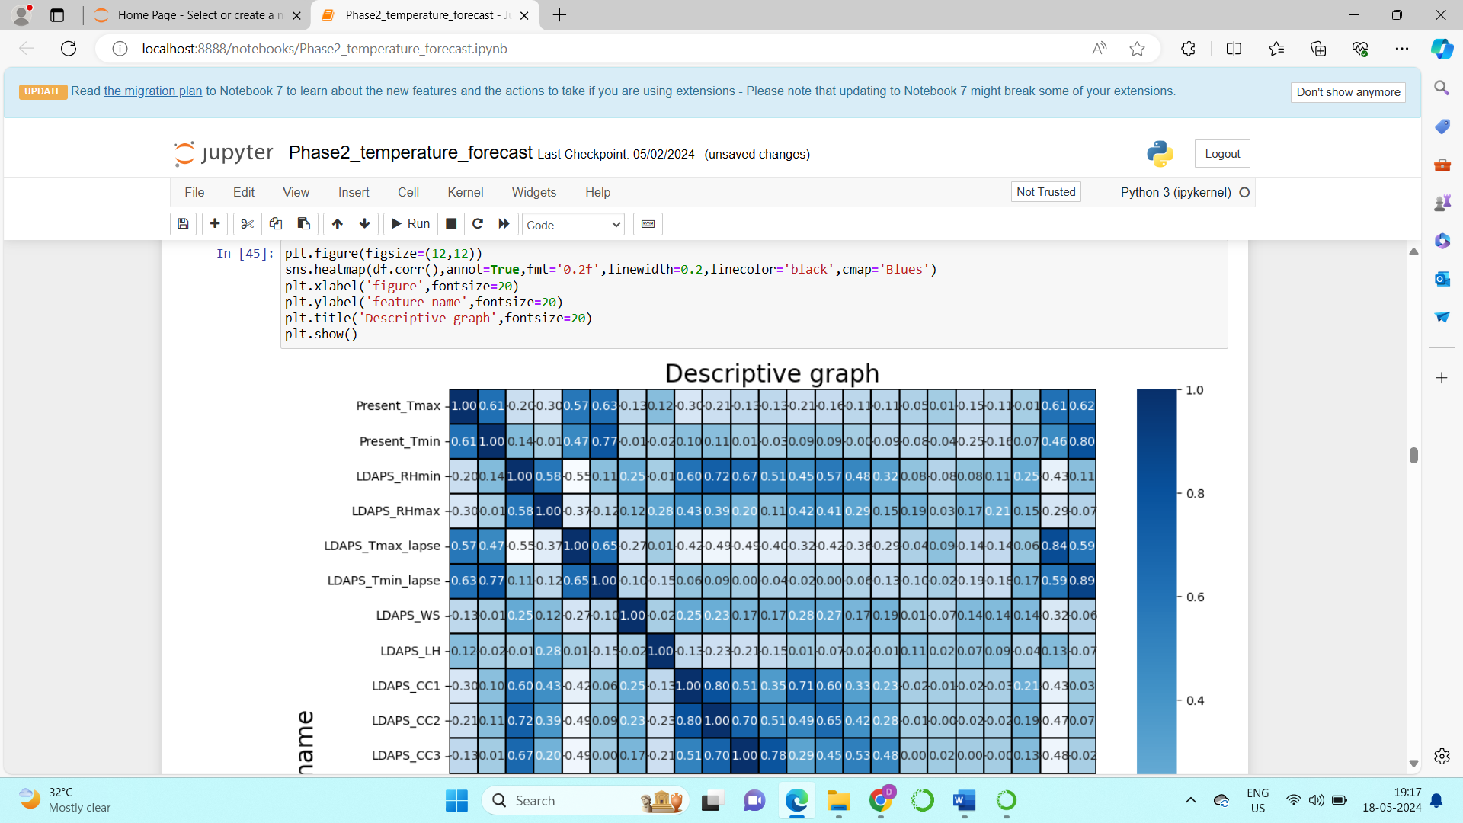

* The below image shows the heatmap of the feature correlation:
* The darker the colour higher those features are correlated.
* The lighter the colour those features are not that much correlated.

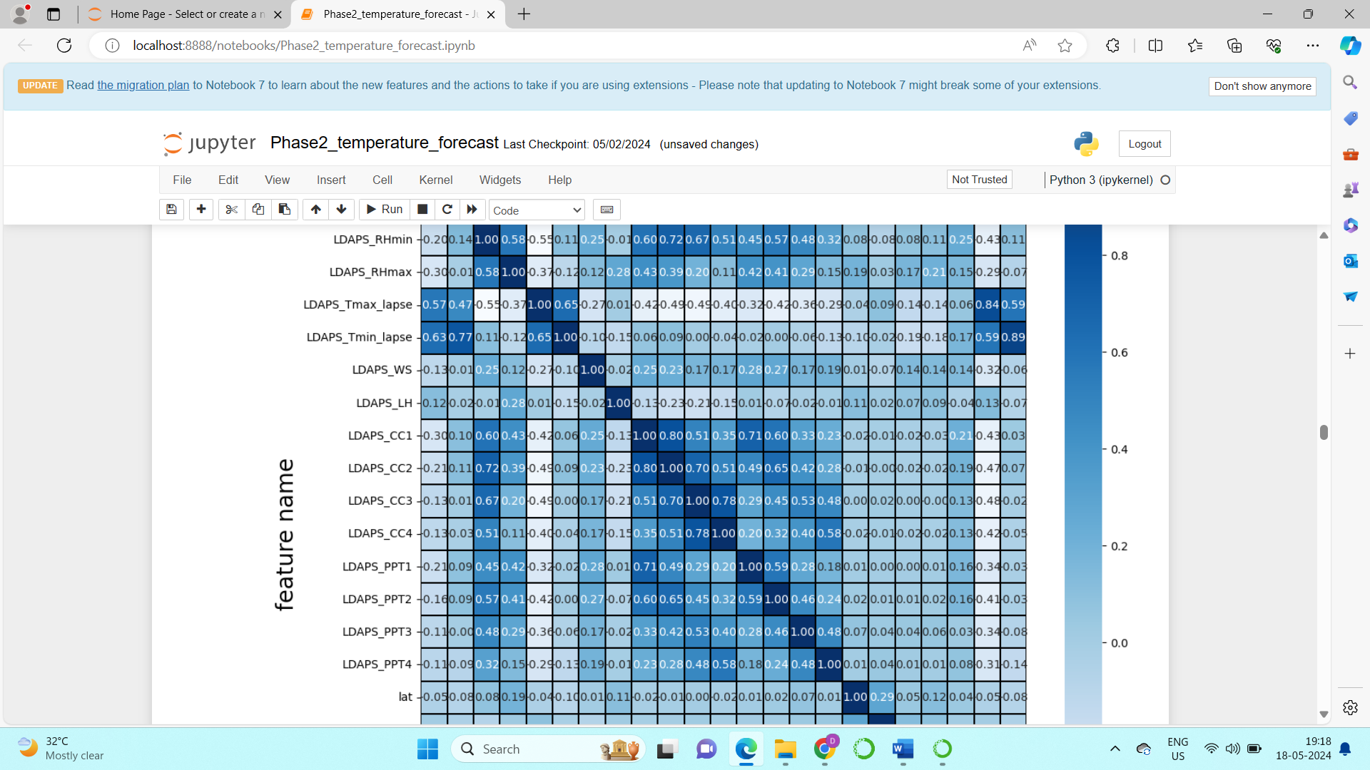

* The next step is we have to remove the features that are highly correlated.
* Along with the heatmap of the correlation with features , another most important thing that is need to be calculated is Variance Inflation Factor.
* It can be calculated using the below mentioned syntax in the image.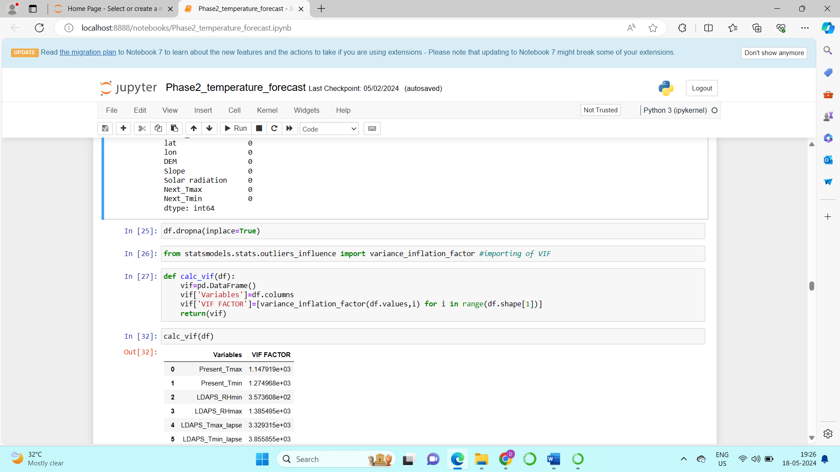
* From the below image you can see that there is no much inflation in the variance, this indicates that even if there is correlation that does not affect much.

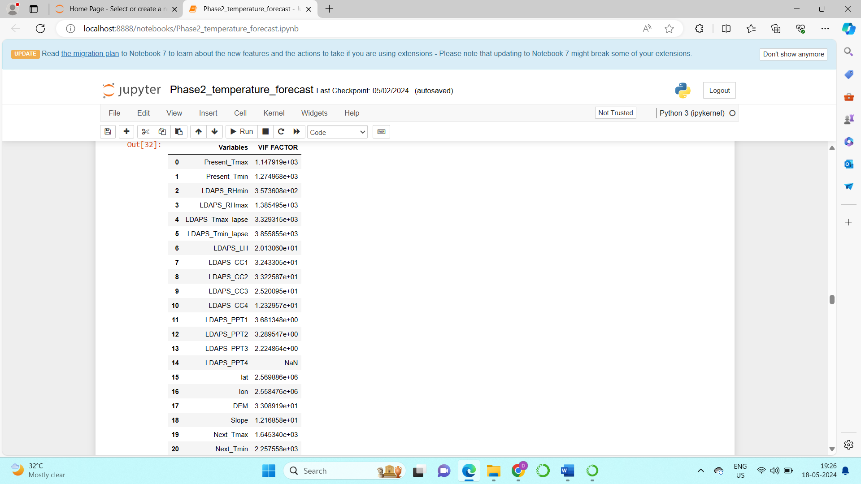

So there is no need to drop the features to remove high correlation.

**Correlation of features with the target:**

Another important step in feature selection is, we have to check how much the feature is correlated with the target.

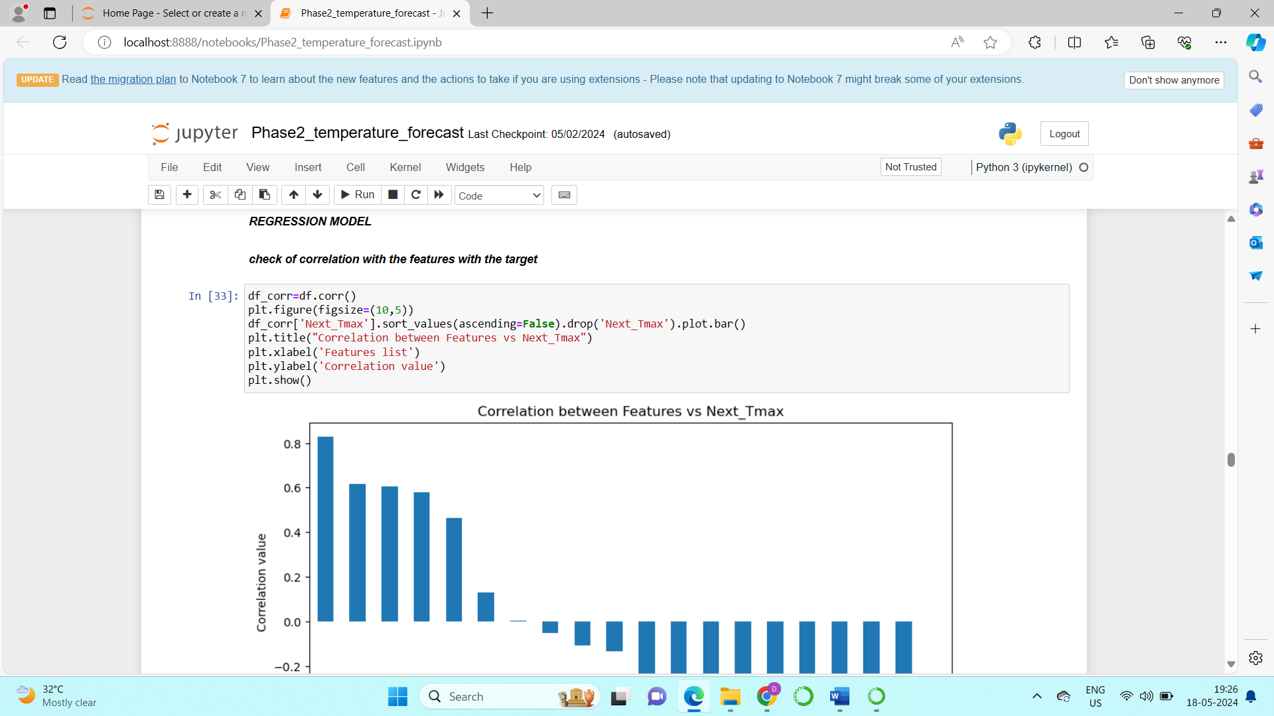

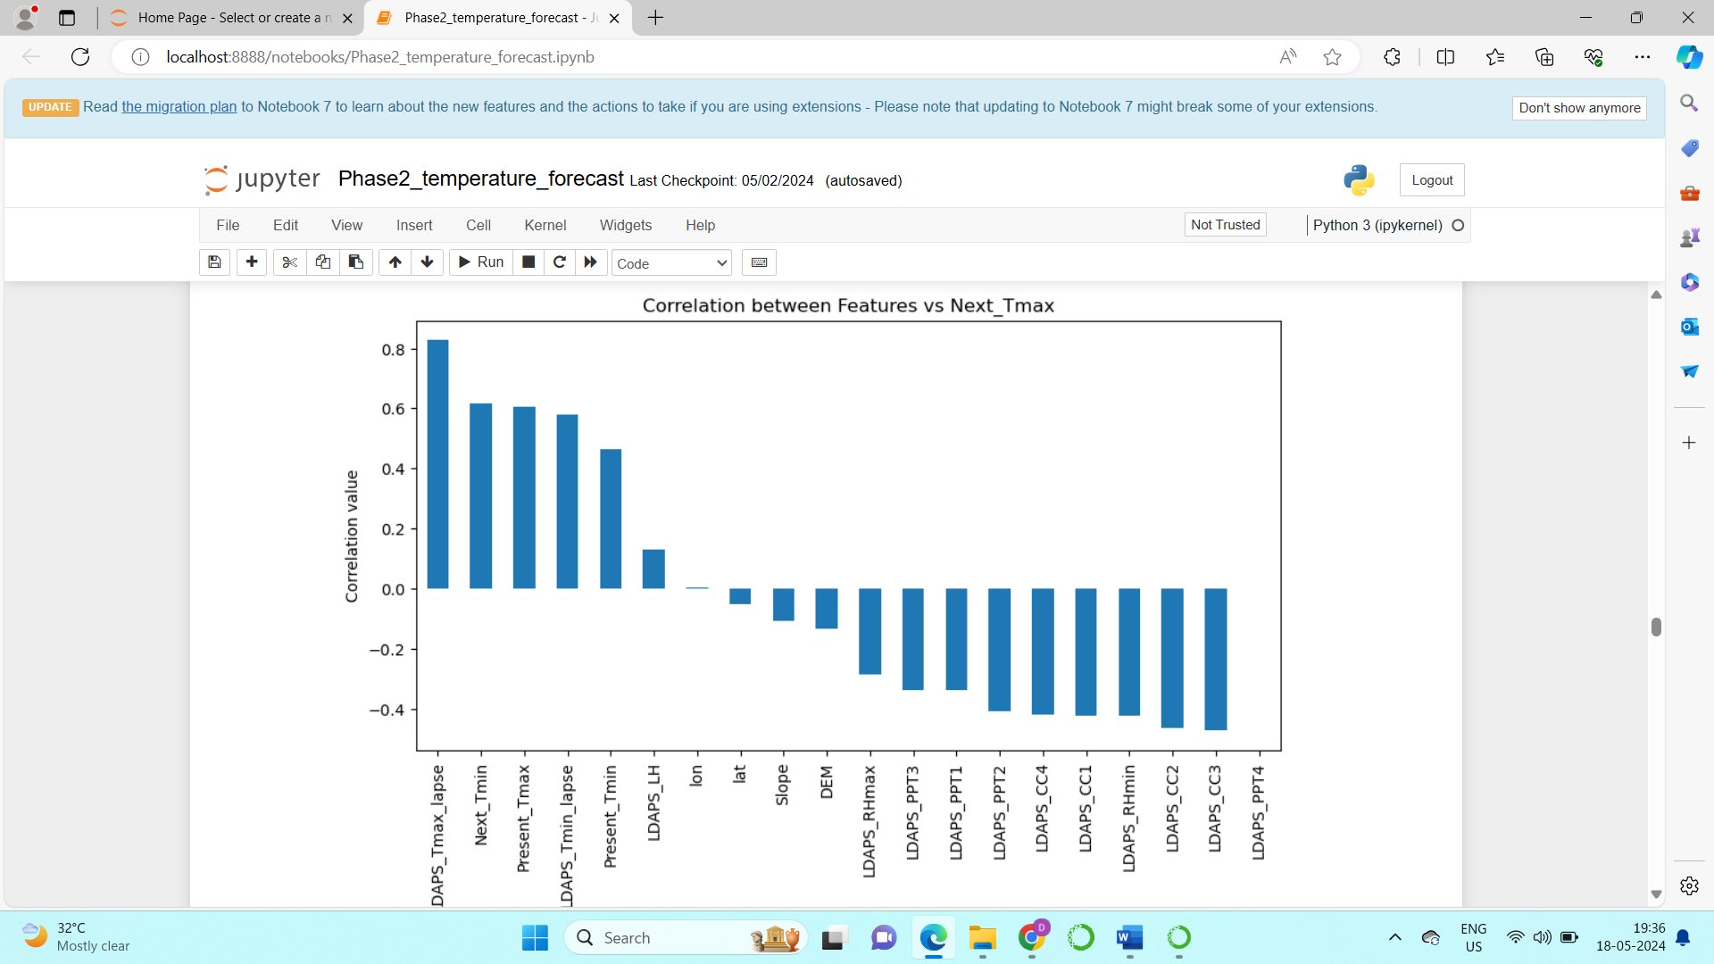

From the above graph we can see that “Latitude”, “Longitude”, “Slope” have least affect on the Target.

So, these features are dropped.

**Normalization of Data:**

* For normalization we use scaling techniques , most familiar scaling technique we use is “Standard Scaler” .
* This is the process which is used to bring all the values in a similar rate to have a better result.
* The below image shows the process and syntax to Standardize the values.

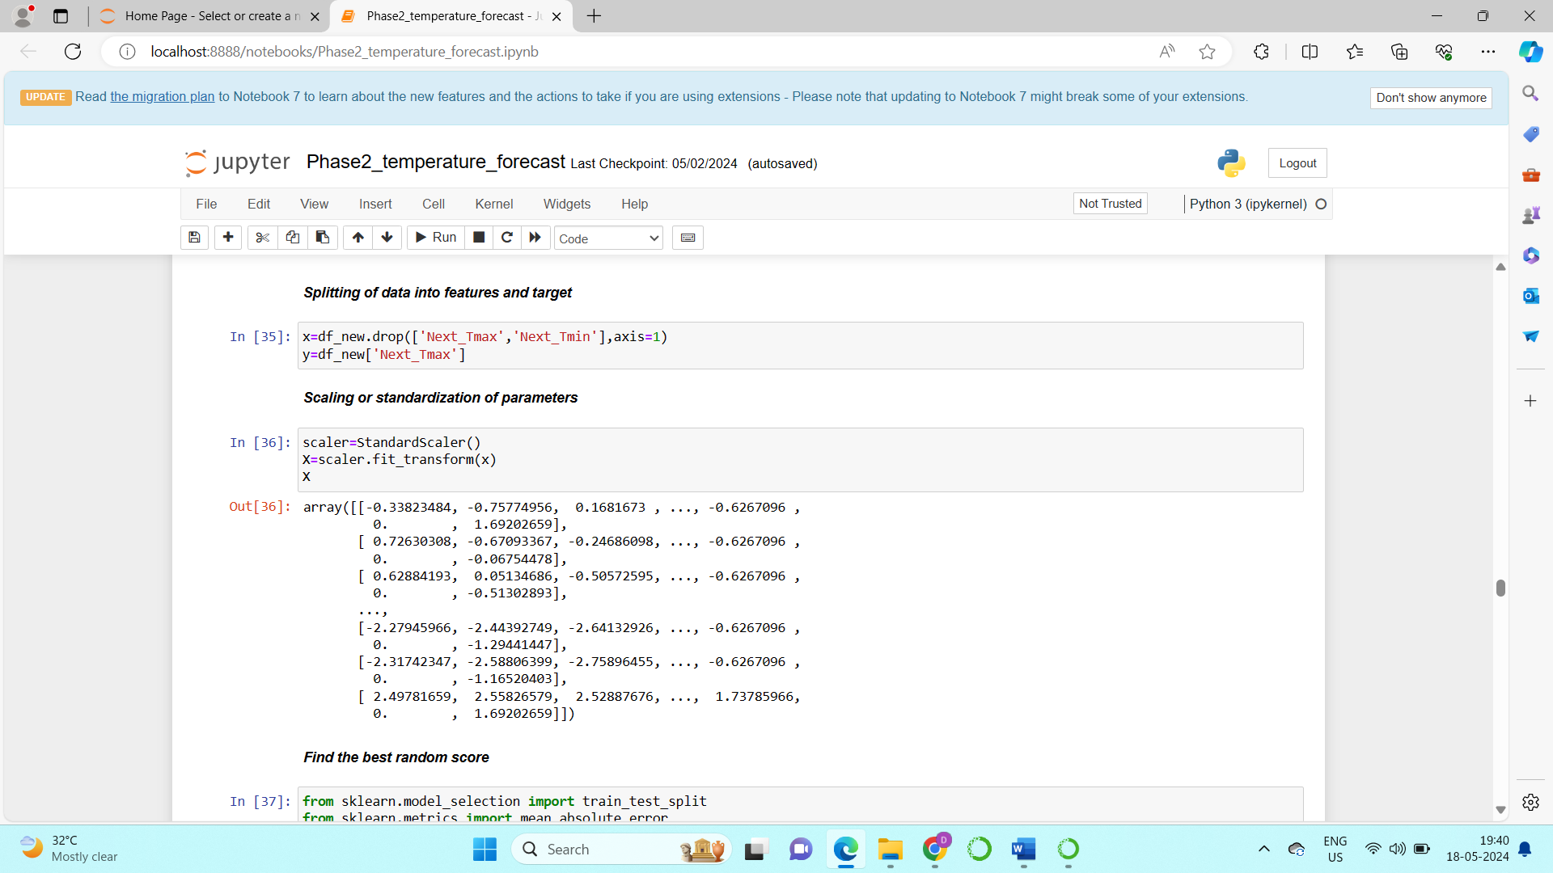

**Splitting of dataset:**

1. **Splitting of dataset “Next day maximum Temperature” as target:**

* The above image shows how the data is been split into two variables x and y.
* “x” is the dependent variables that is the features.
* “y” is the Target.
* These variables are used to train and test the data for preparing the model.

1. **Splitting of dataset “Next day maximum Temperature” as target:**

* The below image shows how the data is been split into two variables x and y.
* “x” is the dependent variables that is the features.
* “y” is the Target.
* These variables are used to train and test the data for preparing the model.
* The standardization is also been done using Standard Scaler.

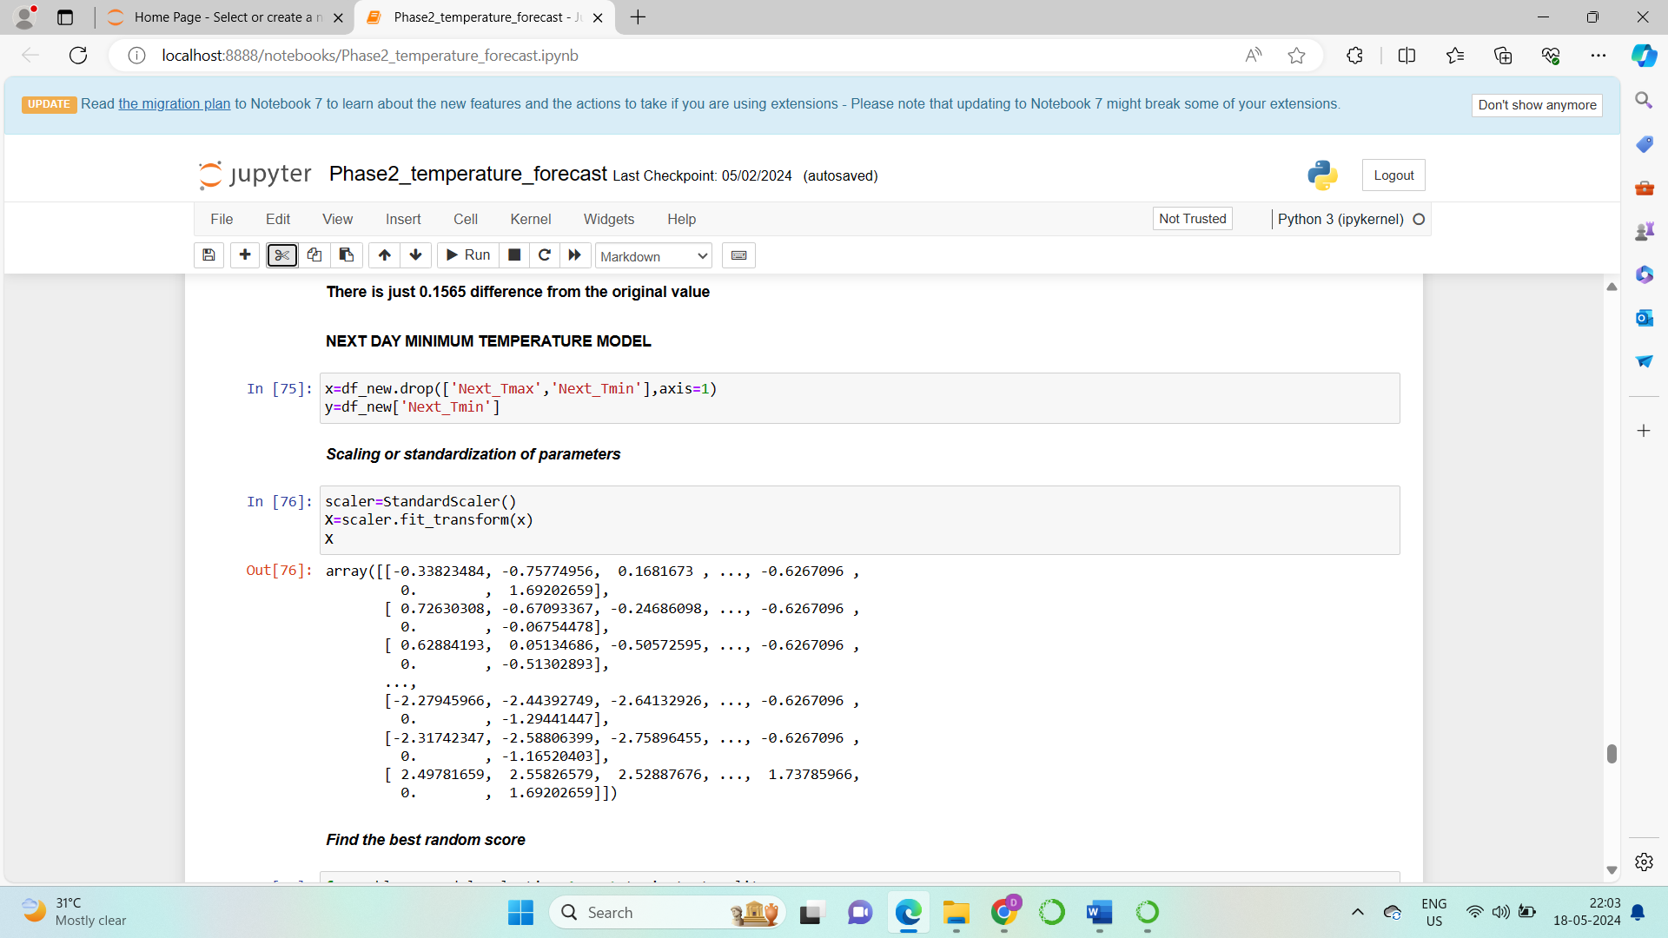

1. **Building machine learning models**

Import all the regression models that are required from sklearn library, which include:

1. Linear Regression
2. Random Forest Regressor
3. Decision Tree
4. K neighbours
5. Lasso and Ridge

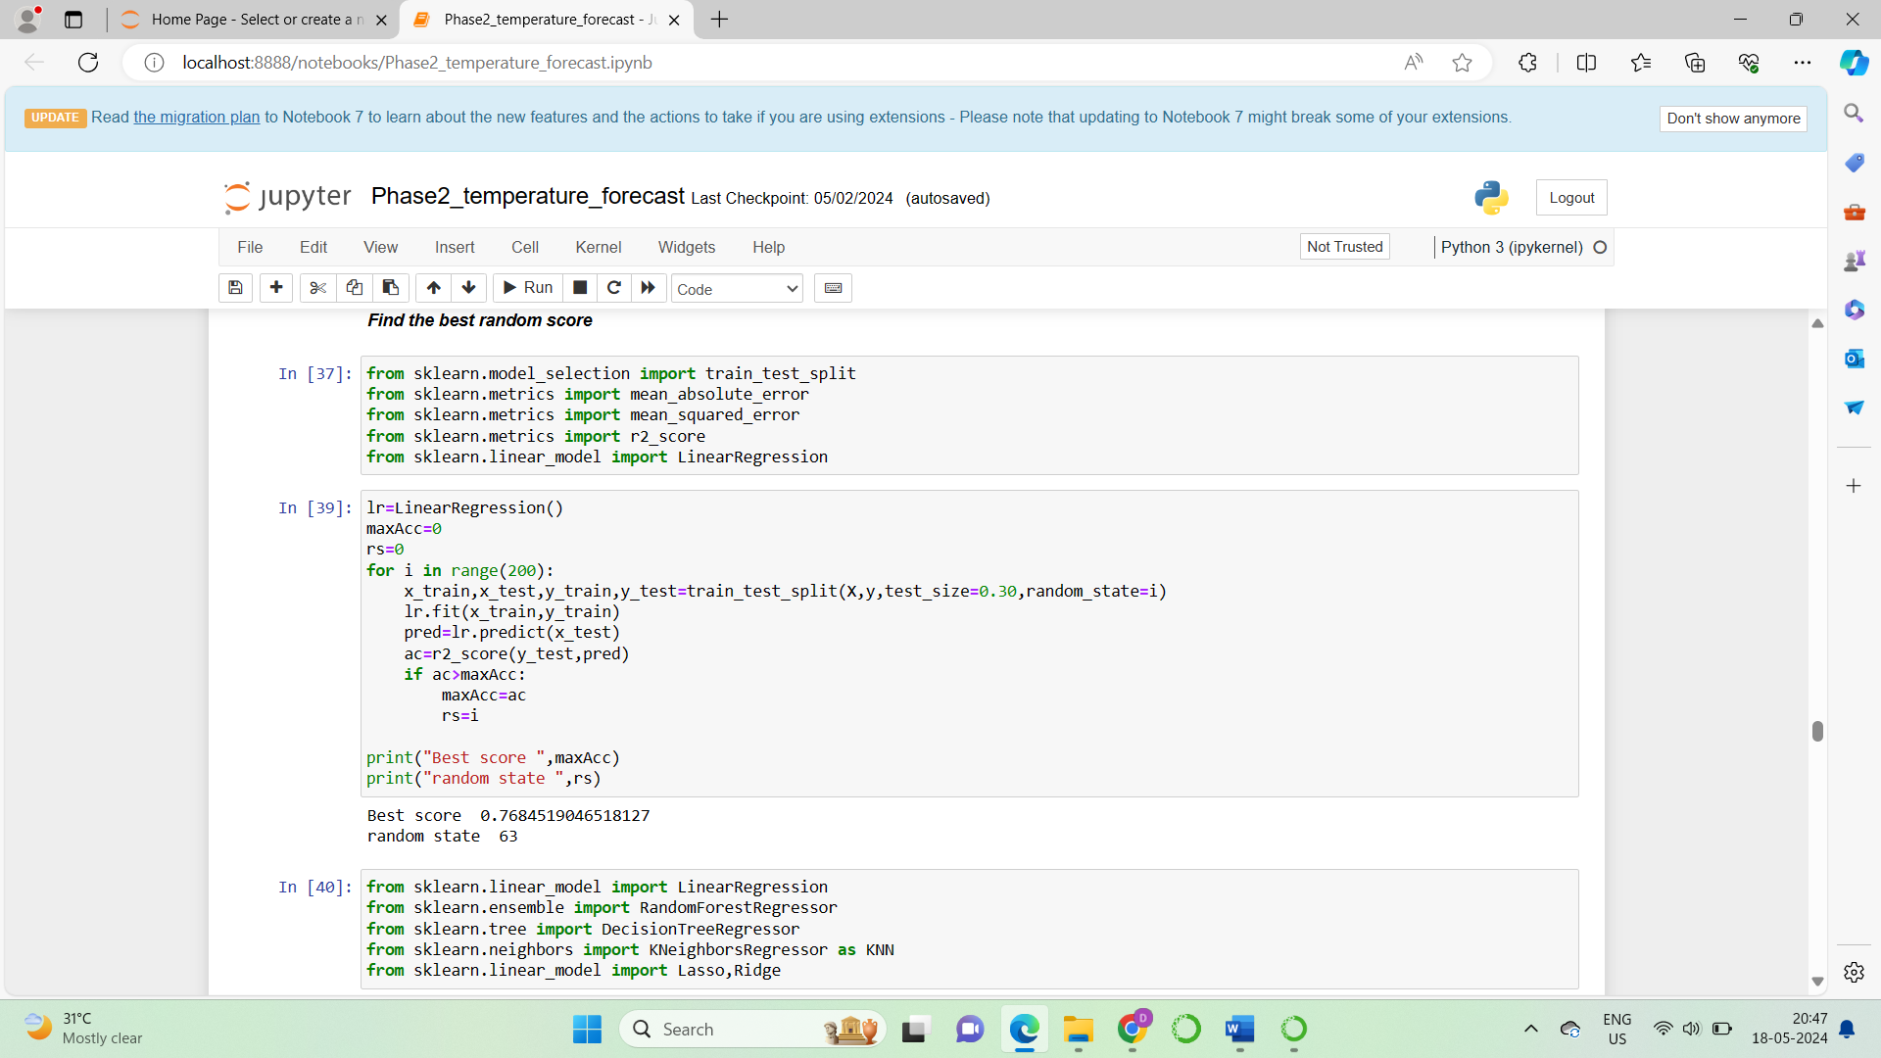

**Find best random score**

* **“Next day maximum Temperature” as target:**
* The above image shows how the random score is found for the model,
* We can see that best random score is “63”. This is random state which gives the best score.
* **“Next day minimum Temperature” as target:**
* The below image shows how the random score is found for the model,
* We can see that best random score is “199”. This is random state which gives the best score.

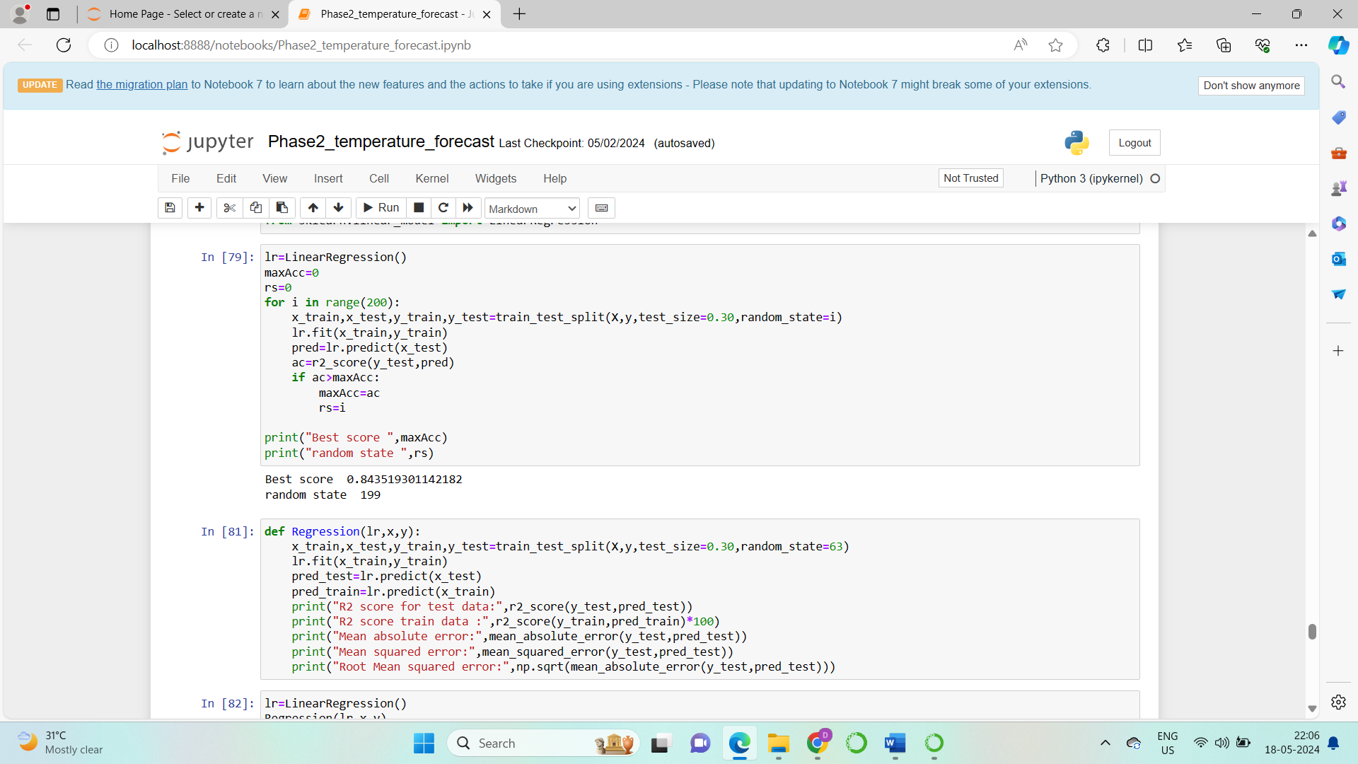

**Find the best model**

I have gone for various models, such as:

1. Linear Regression
2. Random Forest Regressor
3. Decision Tree
4. K neighbours
5. Lasso and Ridge

* **Best model to predict “Next day maximum temperature”**
* The below image shows the results to predict the “Next day maximum temperature”

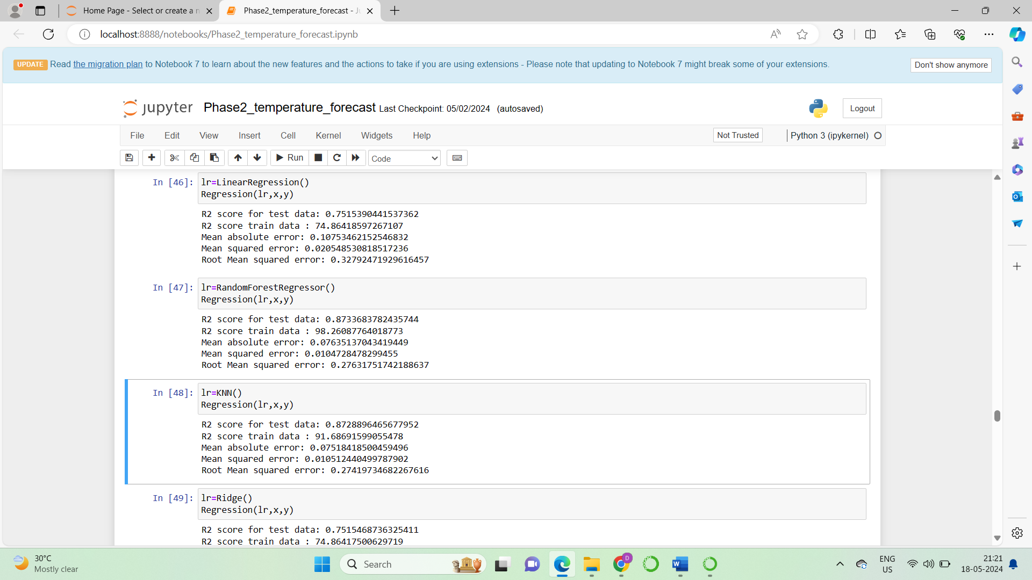

* Out of all these we can see the Random Forest Regressor gives the best results.
* So the model I have selected is Random Forest Regressor .

* **Best model to predict “Next day minimum temperature”**
* The below image shows the results to predict “Next day minimum temperature”.

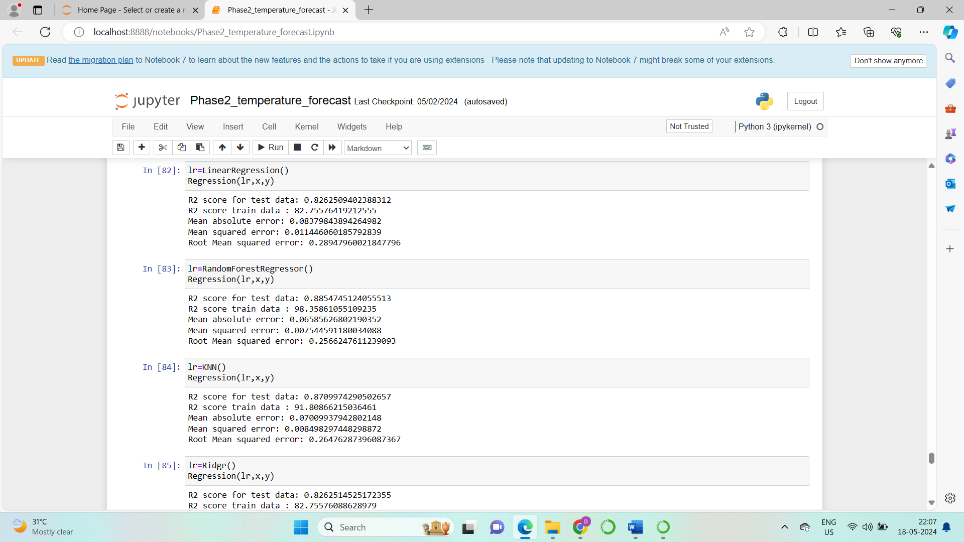

* Out of all these we can see the Random Forest Regressor gives the best results.
* So the model I have selected is Random Forest Regressor.

**Hyperparameter tuning**

This is the method which is used to select the best parameters for the model to give the best results.

For hyperparameter tuning I have used Grid Search CV.

* **Hyperparameter Tuning to predict “Next day maximum temperature”**
* The below image shows the results of the best parameters to predict the “Next day maximum temperature”
* So, we got the best parameters for which the model is created.

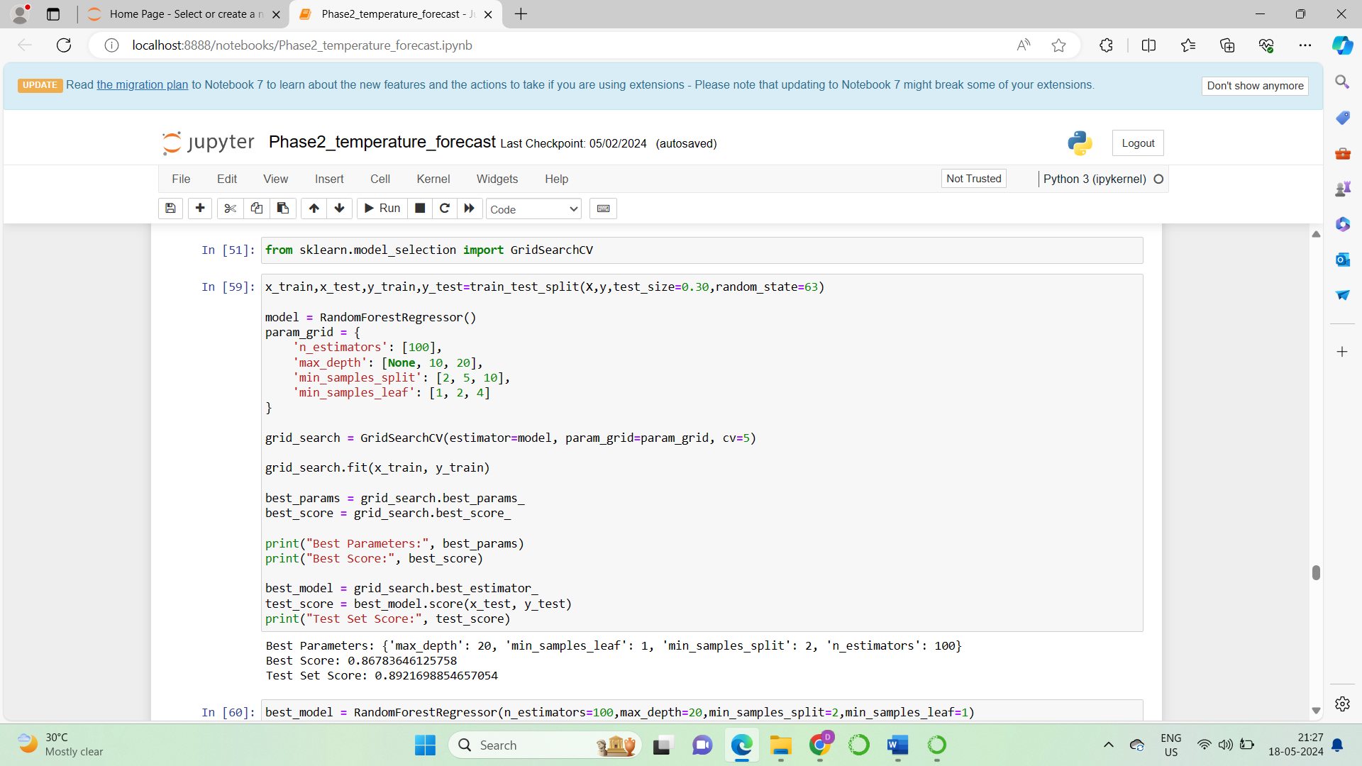

* **Hyperparameter Tuning to predict “Next day minimum temperature”**
* The below image shows the results of the best parameters to predict the “Next day maximum temperature”
* So, we got the best parameters for which the model is created.

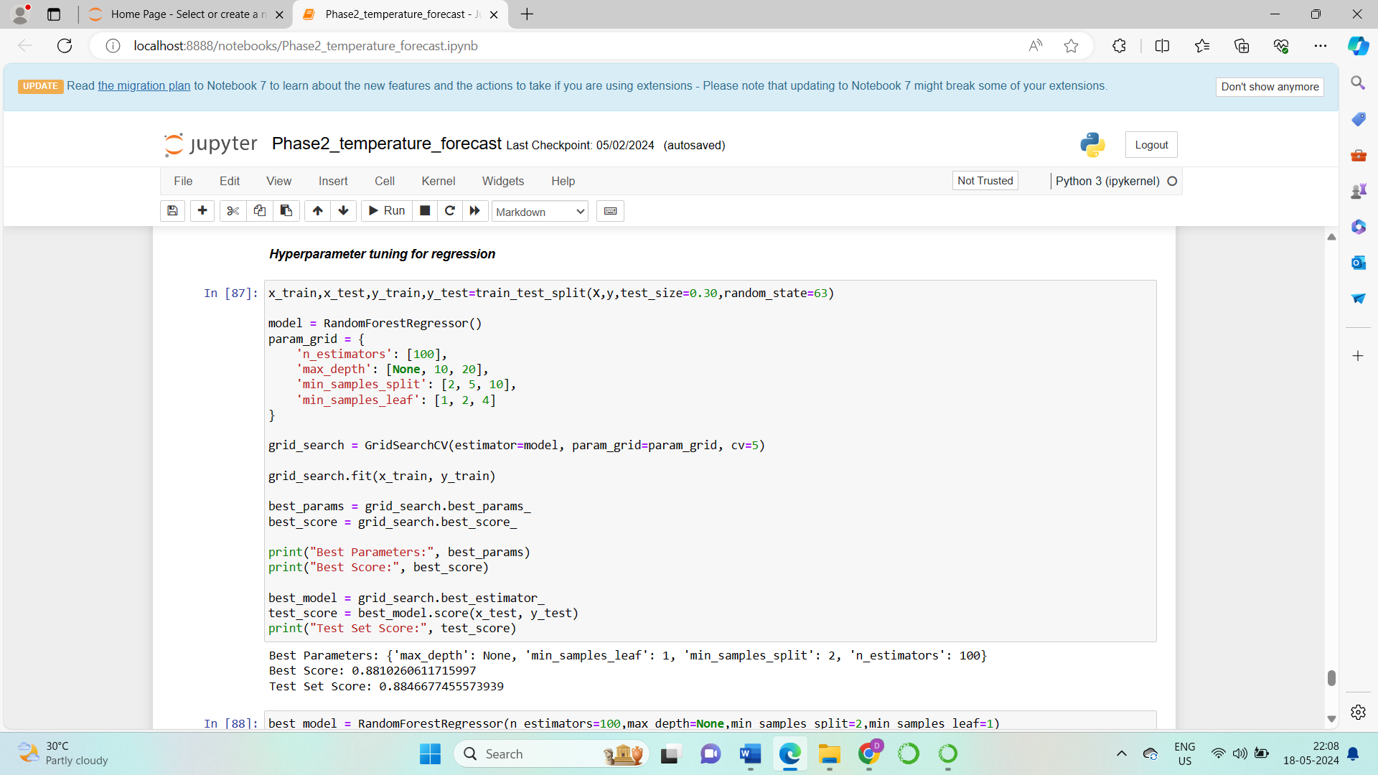

**Creation of final model**

* **Creation of final model to predict “Next day maximum temperature”**
* The final model to predict “Next day maximum temperature” is created with its best parameters as shown in the below image.

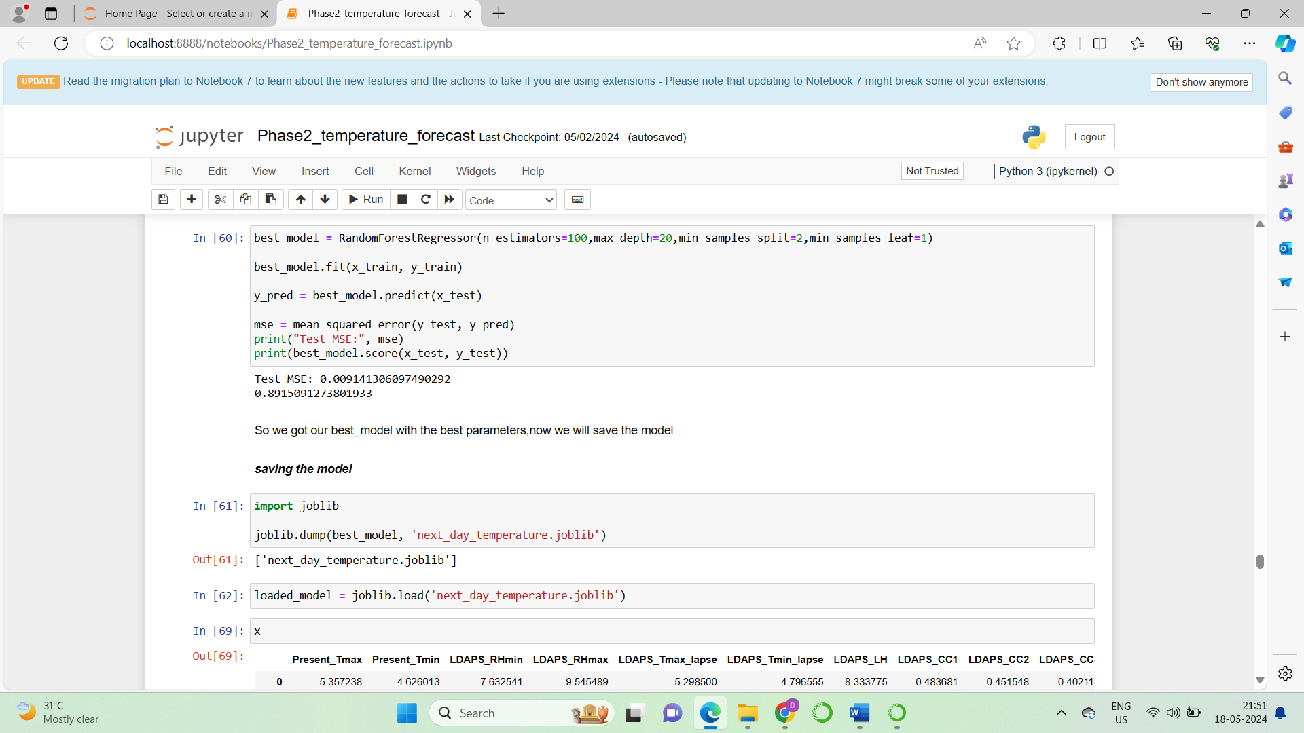

* **Creation of final model to predict “Next day minimum temperature”**
* The final model to predict “Next day minimum temperature” is created with its best parameters as shown in the below image.

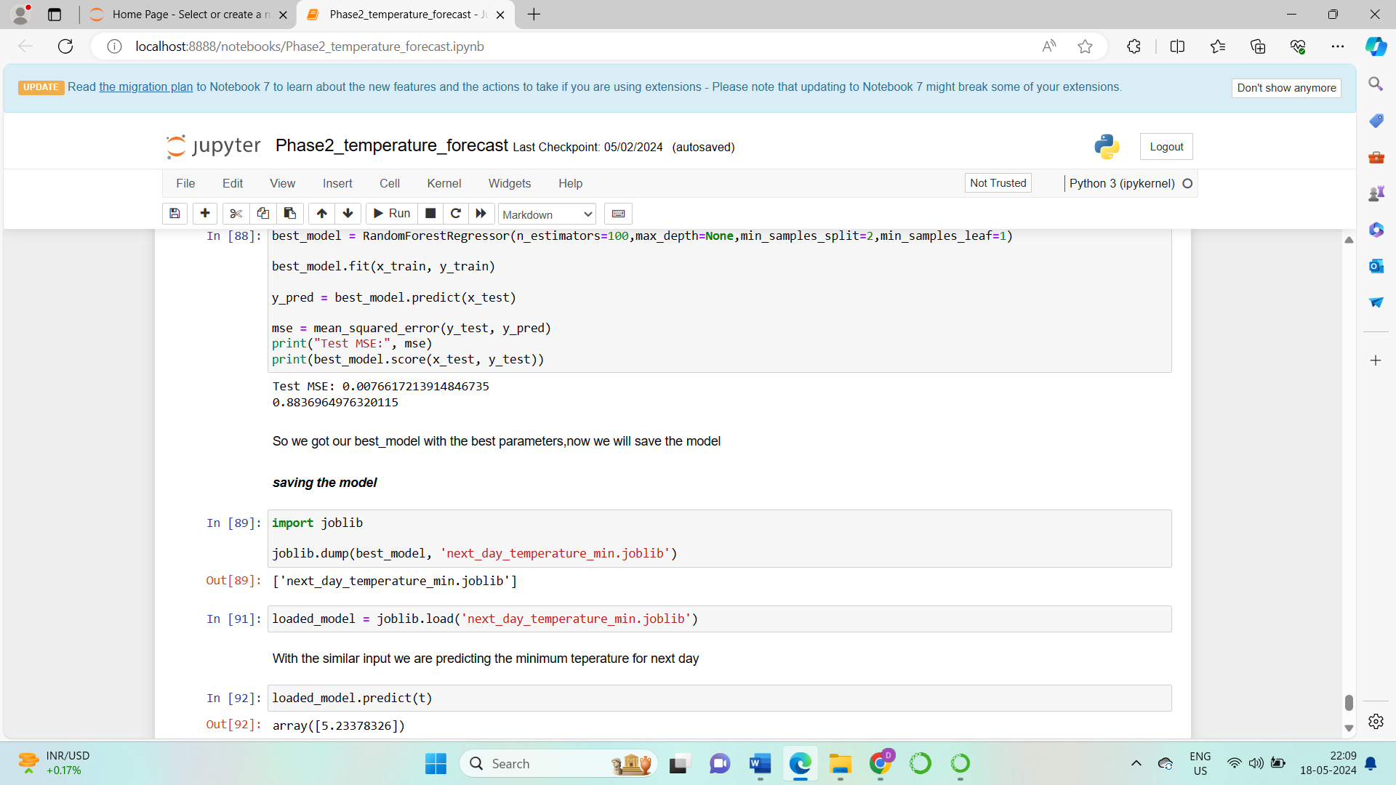

**Saving and testing the model**

* **Saving and testing the model to predict “Next day maximum temperature”**
* The final model to predict “Next day maximum temperature” is saved using joblib module and tested giving accurate results as shown in the image below.

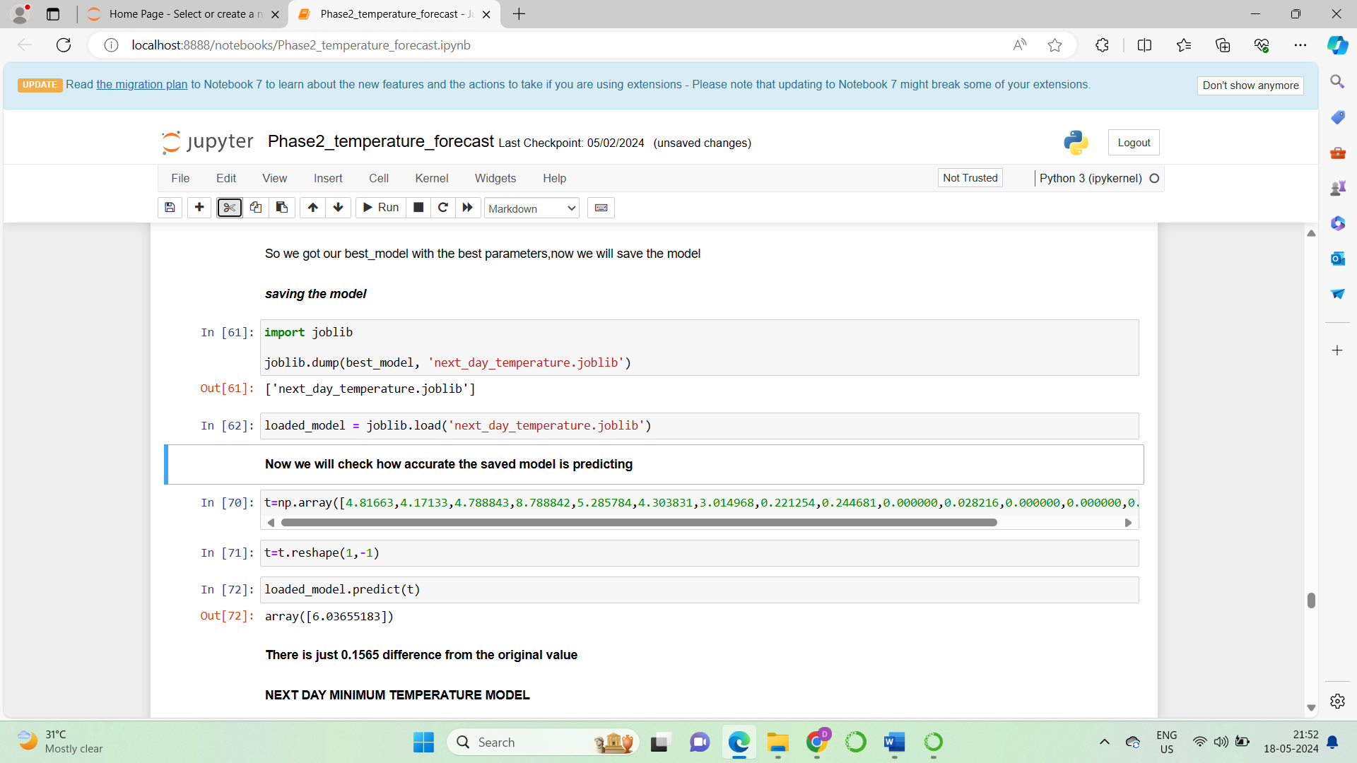

* **Saving and testing the model to predict “Next day minimum temperature”**
* The final model to predict “Next day miniimum temperature” is saved using joblib module and tested giving accurate results as shown in the image below.



1. **Concluding Remarks**

**Summary of findings**

In this project, we aimed to enhance the accuracy of temperature forecasts in Seoul, South Korea, by leveraging historical weather data from the Korea Meteorological Administration. Our focus was on predicting the next day's maximum and minimum temperatures using a variety of regression techniques. Here's a summary of our approach and findings:

Accurate weather forecasting is crucial for multiple sectors, and improving existing models can significantly benefit these areas. We aimed to refine next-day temperature predictions using historical data and regression analysis.

**Outcome**

The developed Random Forest Regressor model significantly improved the accuracy of next-day maximum and minimum temperature predictions. This enhancement can aid better preparedness and decision-making across various weather-dependent sectors.

**Final Thoughts**

This project successfully demonstrated how historical data and advanced regression techniques can be leveraged to refine weather forecasts. By systematically preprocessing the data, selecting the most relevant features, and employing robust modelling techniques, we achieved more accurate and reliable temperature predictions for Seoul. This approach can be extended to other regions and forecasting models, contributing to more precise and actionable weather insights globally.